How to Complete and Submit the DHCD M/WBE Self Evaluation

As part of the full application submission to DHCD, each sponsor is required to put together a written MBE & WBE plan that outlines the sponsor’s commitment to diverse development team assembly and diverse supplier contracting and is specific to the project for which the sponsor is submitting a full application.

While DHCD’s M/WBE Self Evaluation includes instructions for how to put together a comprehensive and robust written MBE & WBE plan, there is no set template for this written plan; it is up to the sponsor to decide what information to include. Sponsors are encouraged to watch DHCD’s recorded webinar on the M/WBE Self-Evaluation prior to drafting the narrative plan and completing the self-evaluation.

Once the sponsor has written the plan, the sponsor should proceed to complete the M/WBE Self Evaluation as follows:

- Open the M/WBE Self Evaluation and scroll down to the section titled “MBE & WBE and Section 3 Form”.
  - If you do not have a copy of the M/WBE Self Evaluation, you can download it from CEDAC’s website.
- Fill in the requested information in the “MBE & WBE and Section 3 Form” based on the information included in the sponsor’s written MBE & WBE plan.
- Attach the completed “MBE & WBE and Section 3 Form” to the end of the written MBE & WBE plan in either pdf or Word format. This combined document serves as Exhibit 32.2 for the purpose of uploading the information to Intelligrants.
  - For information on how to upload the combined Exhibit 32.2 document to Intelligrants, please see the instructions on the following page.
- Upload the combined document as Exhibit 32.2 in Intelligrants.
- Separately, email the combined document (i.e. the written plan and the completed “MBE & WBE and Section 3 Form” attached to the end of the plan) to Kate Racer (catherine.racer@mass.gov) and Rebecca Frawley Wachtel (rebecca.frawley@mass.gov) at DHCD.

If you have any questions about the M/WBE Self Evaluation or how to submit it, please contact Will Morgan at wmorgan@cedac.org.

Instructions for Uploading Exhibit 32.2 to Intelligrants

Once the sponsor has attached the completed “MBE & WBE and Section 3 Form” to the end of the written MBE & WBE plan, the combined document should be uploaded to Intelligrants as Exhibit 32.2, using the following instructions.

- In Intelligrants, navigate to the project’s OneStop
- On the “Rental OneStop Menu” page, click the “Forms” button (highlighted in yellow).

- On the next page, click the “Document Upload Management Module” button in the “Exhibits” section. Once clicked, a separate window titled “Rental OneStop Menu – Document Upload Management” will open in your internet browser.
- In the new “Document Upload Management” window, click the “Monitoring/Compliance” button.
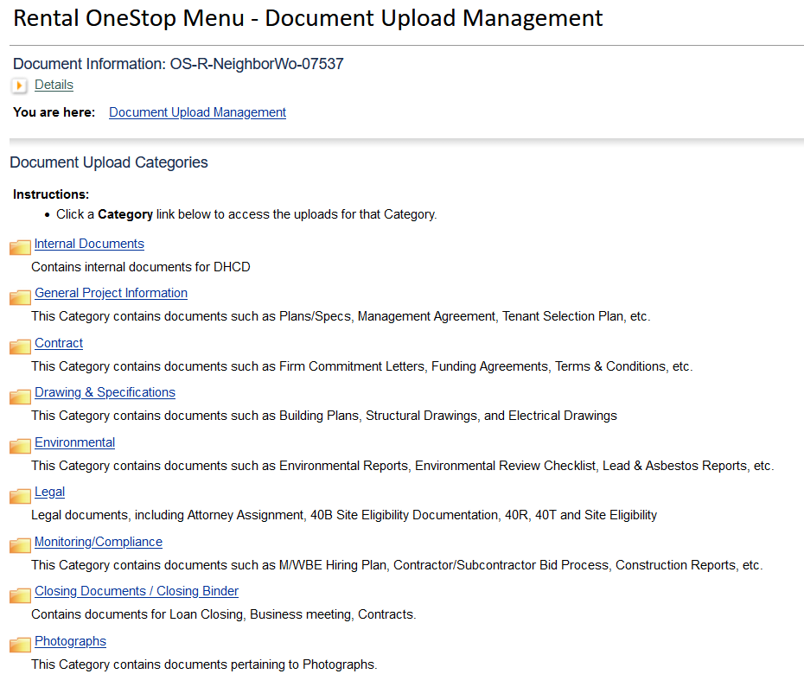
- On the next page, select “MBE/WBE & Section 3” from the “Subcategories” drop-down menu.

- On the next page, in the second row labeled “Exh. 32.2 Narrative M/WBE Hiring Plan,” click on the number in the “Current Version” column.
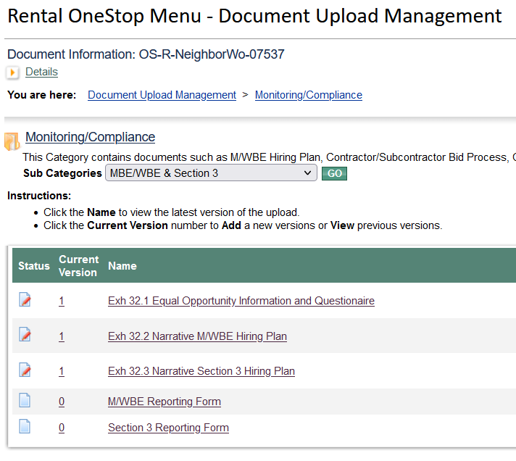

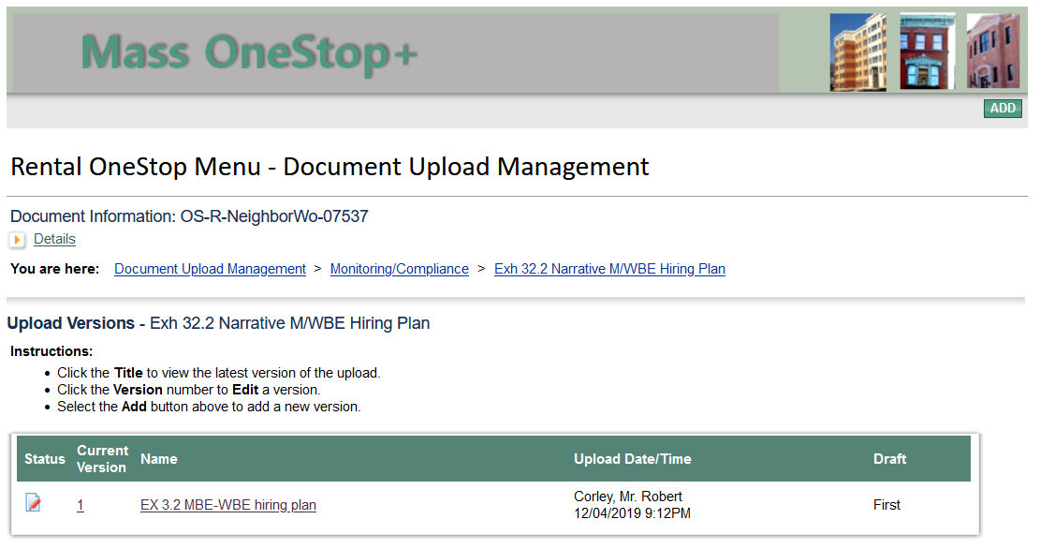
- On the next page, click the “Add” button in the top-right corner.

- On the next page, click the “Browse” button. A new window will open on your screen.

- In the new window, browse to the location on your computer where the combined Exhibit 32.2 document is saved. Click on the document name and then click “Open.”
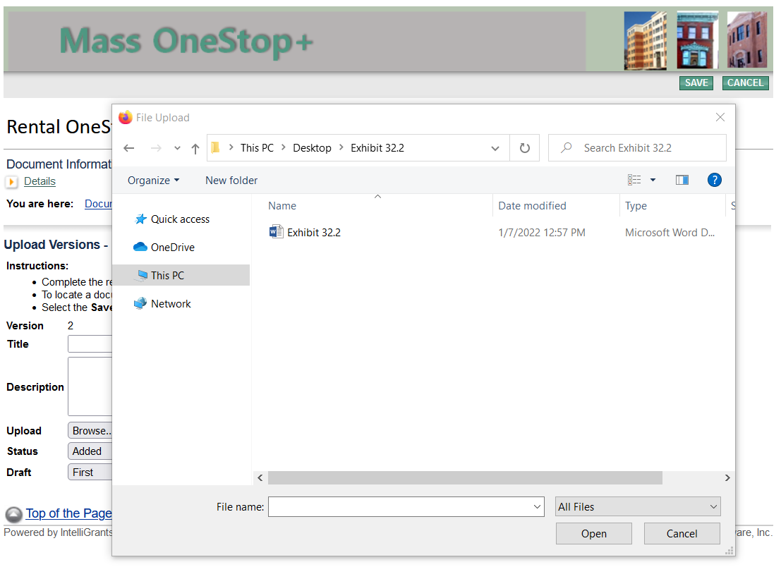

- On the next page, click “Save” in the top-right corner. This is the final step.

